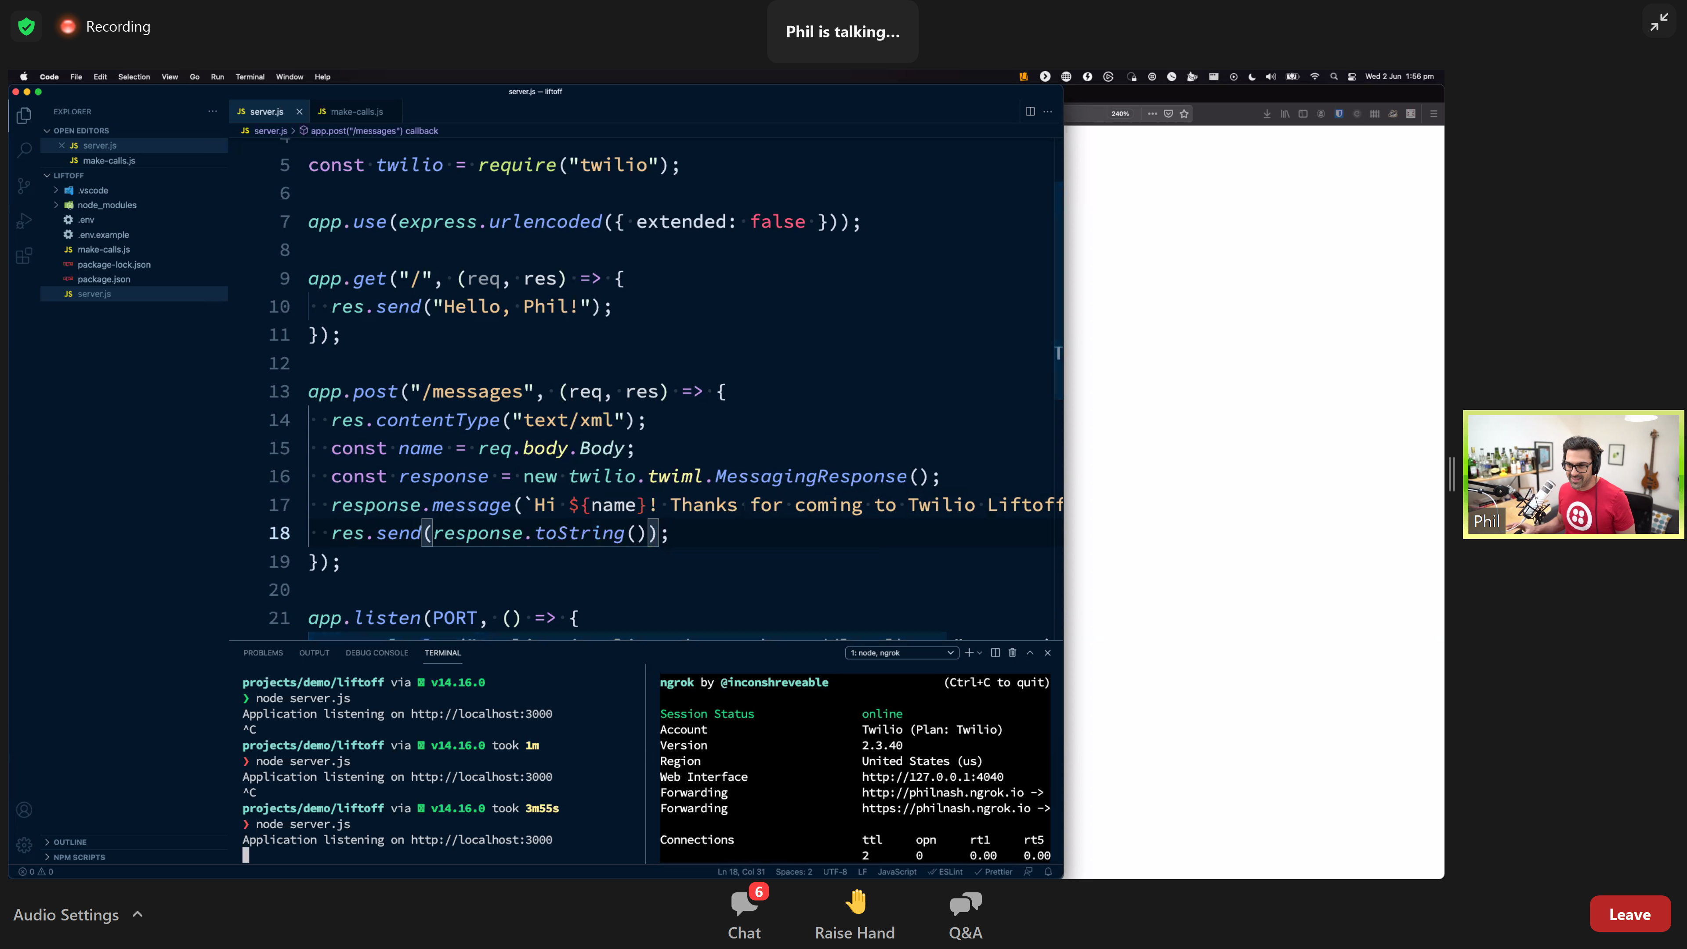

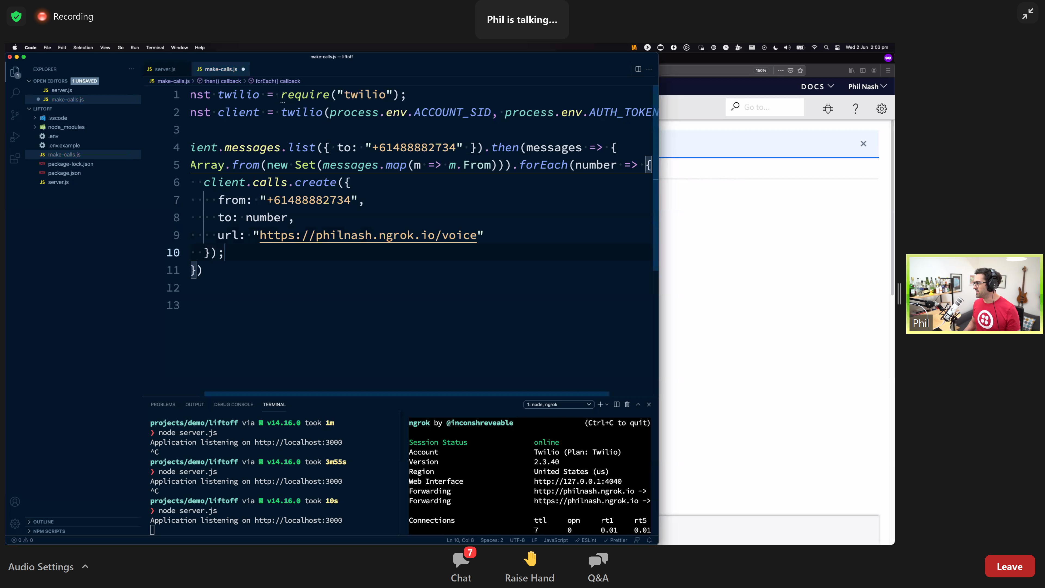

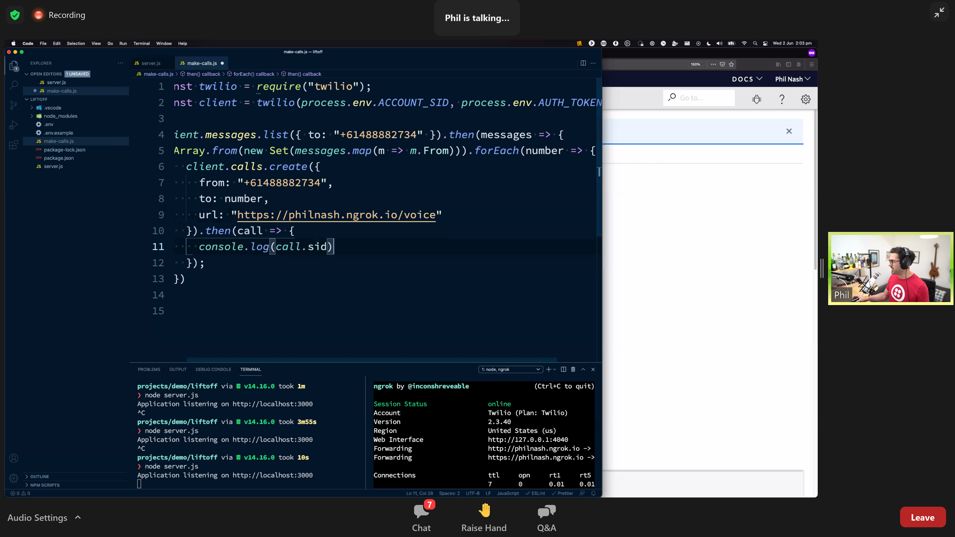

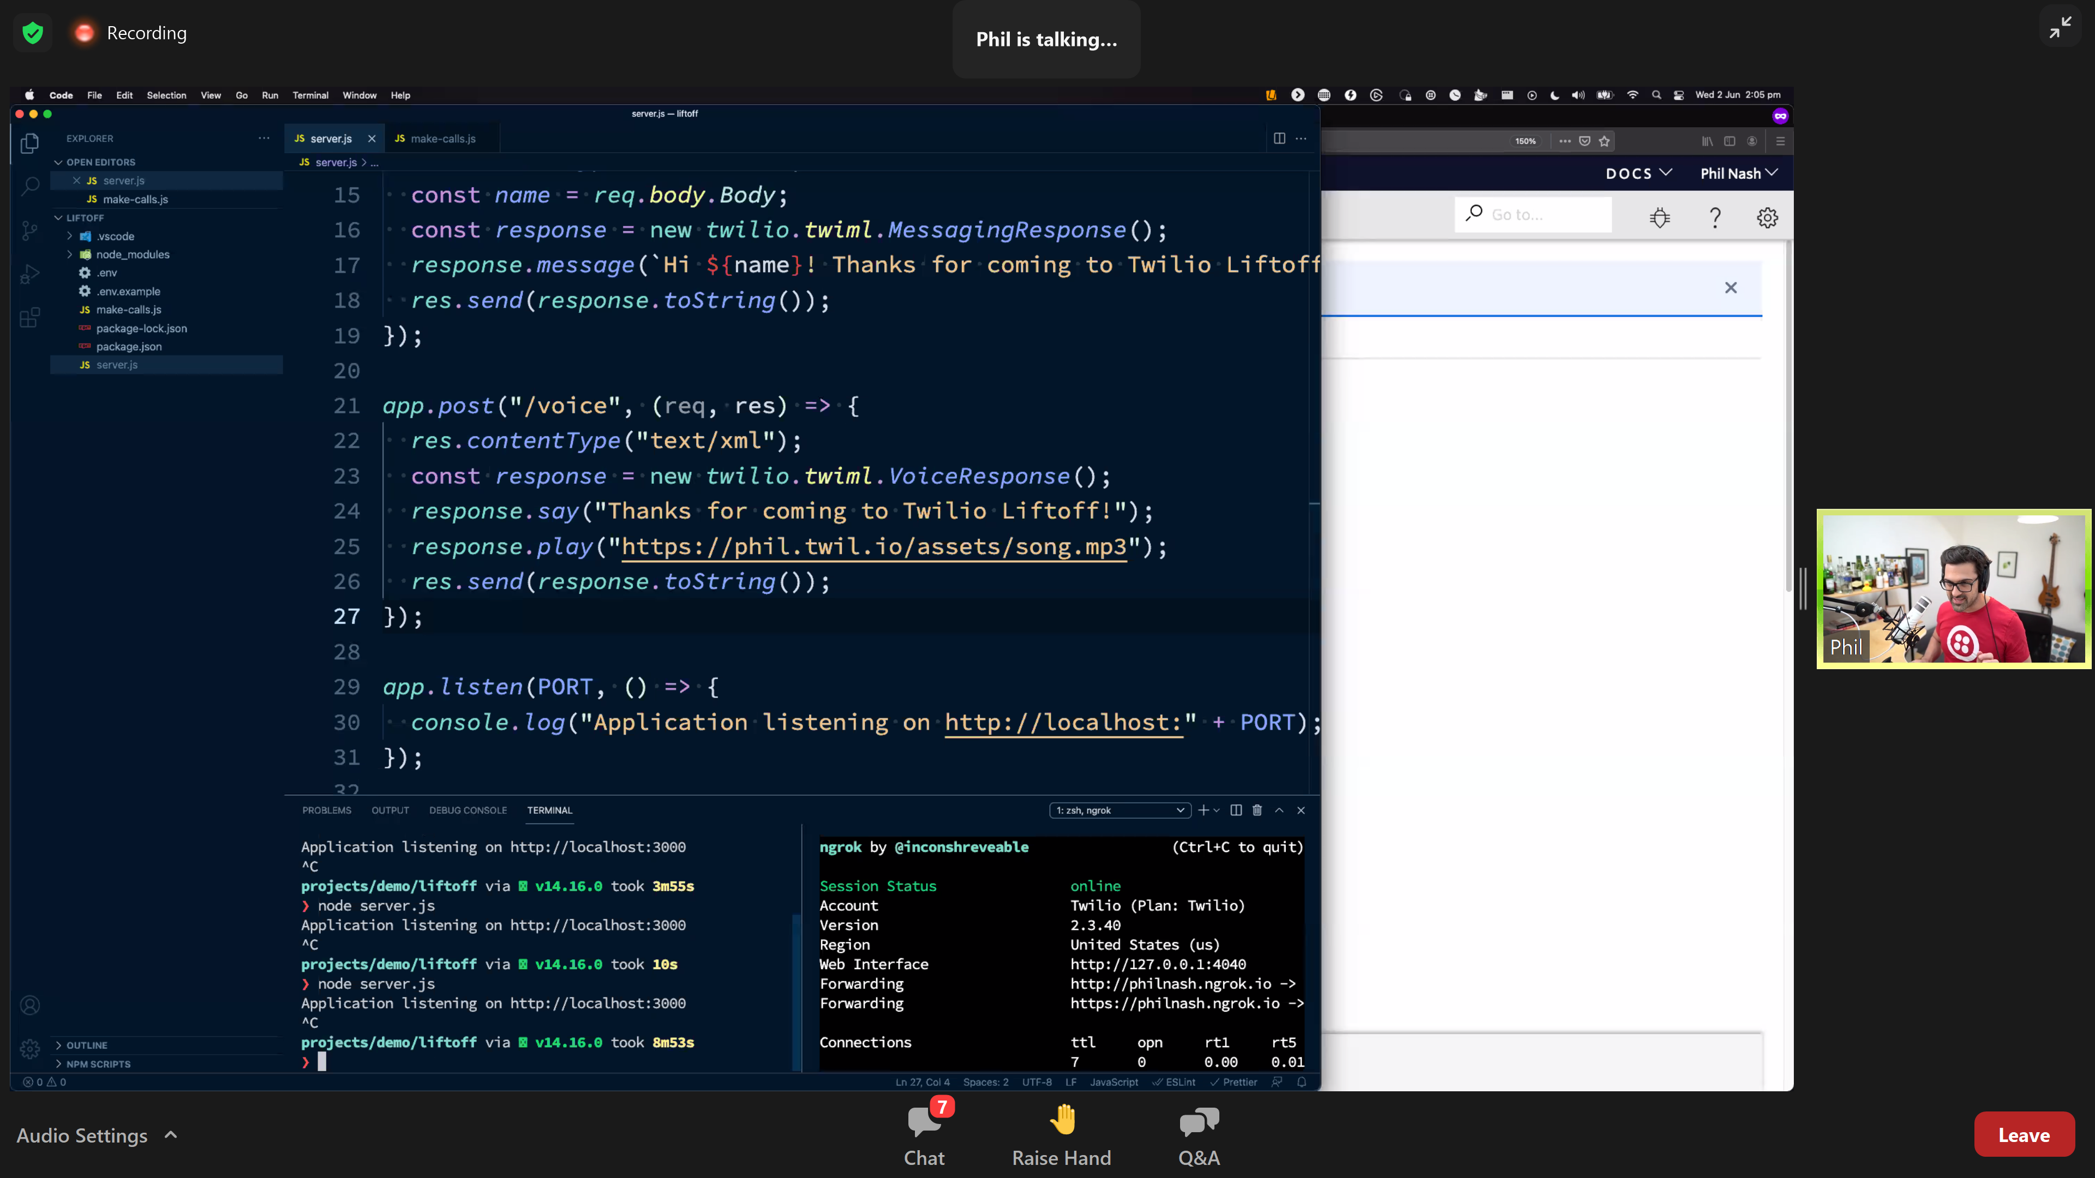

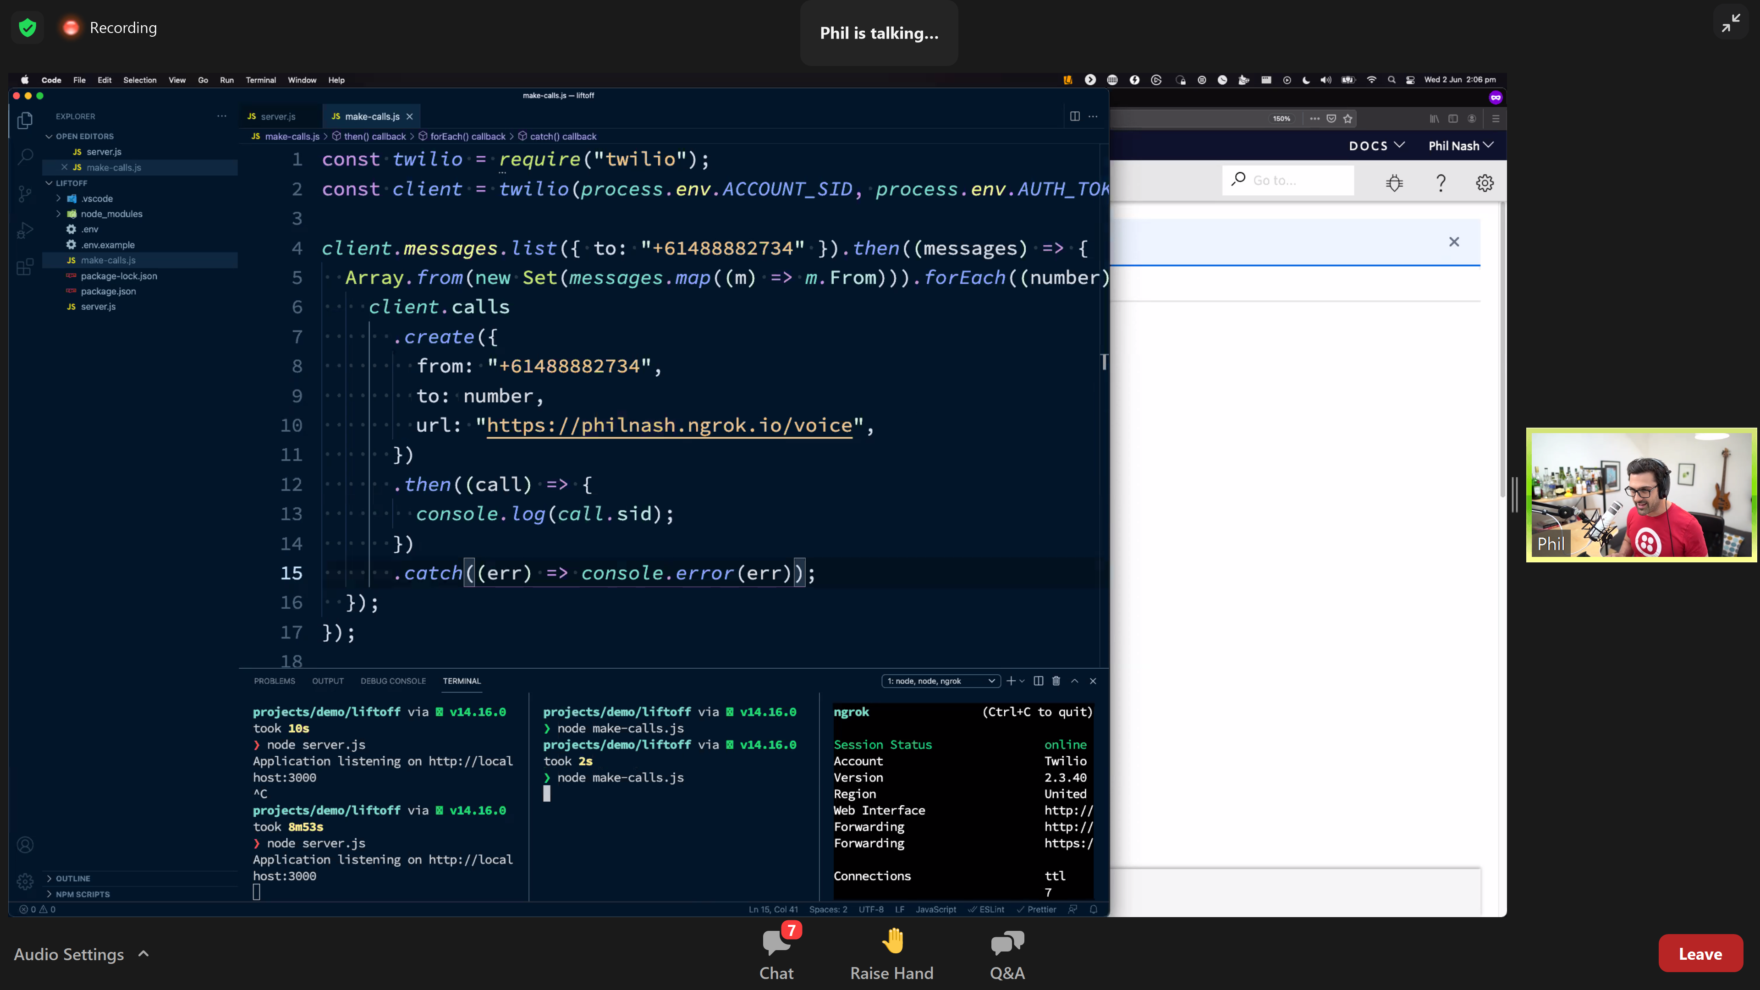

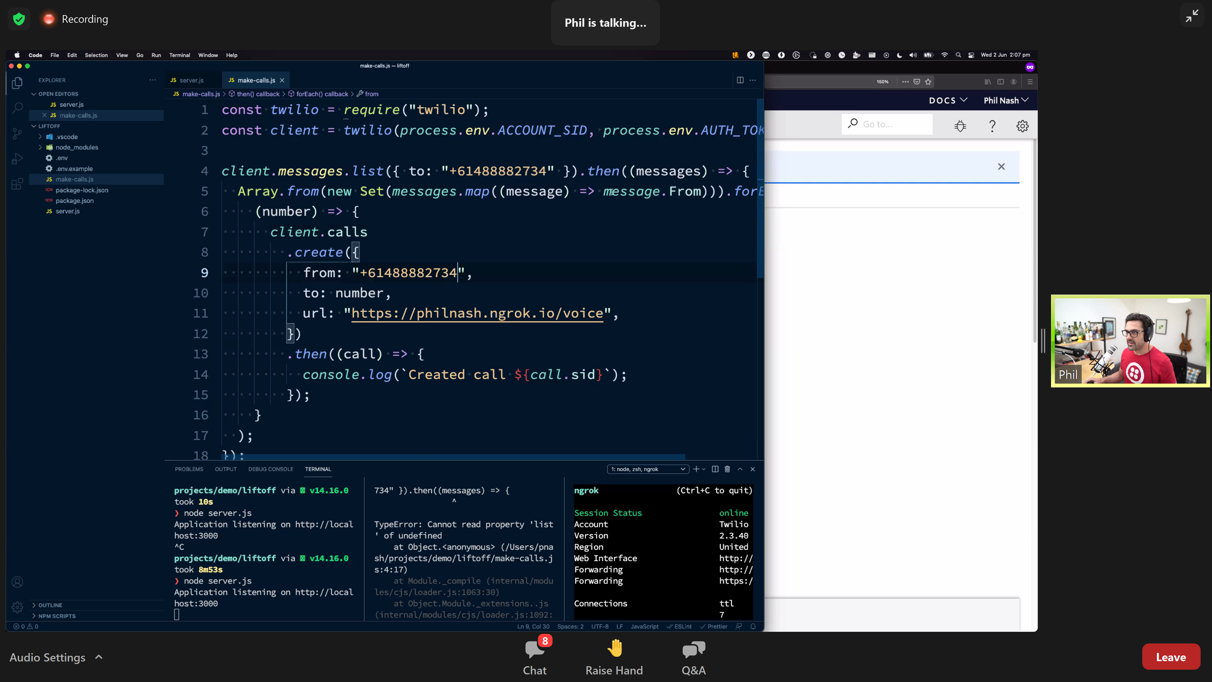

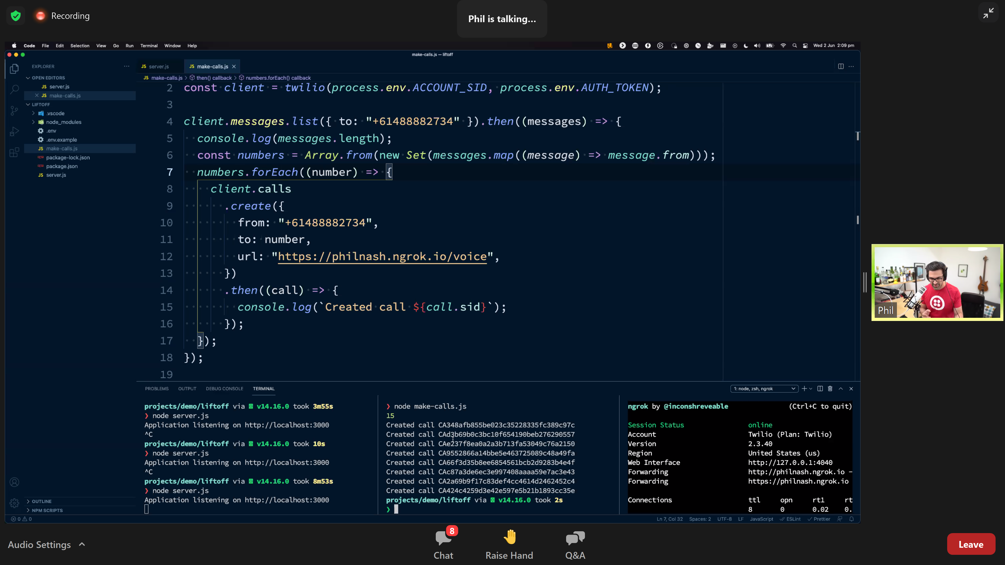

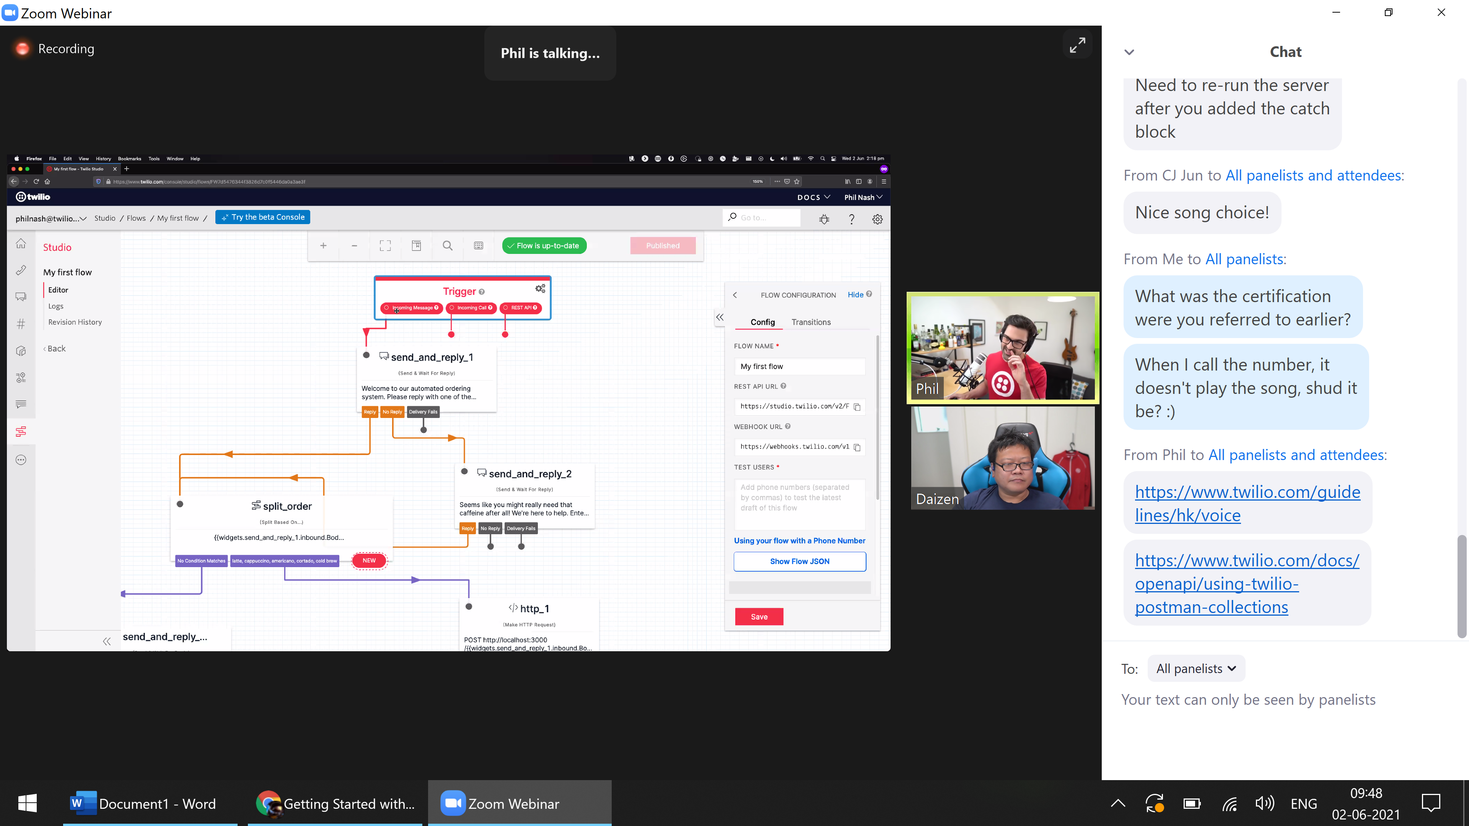

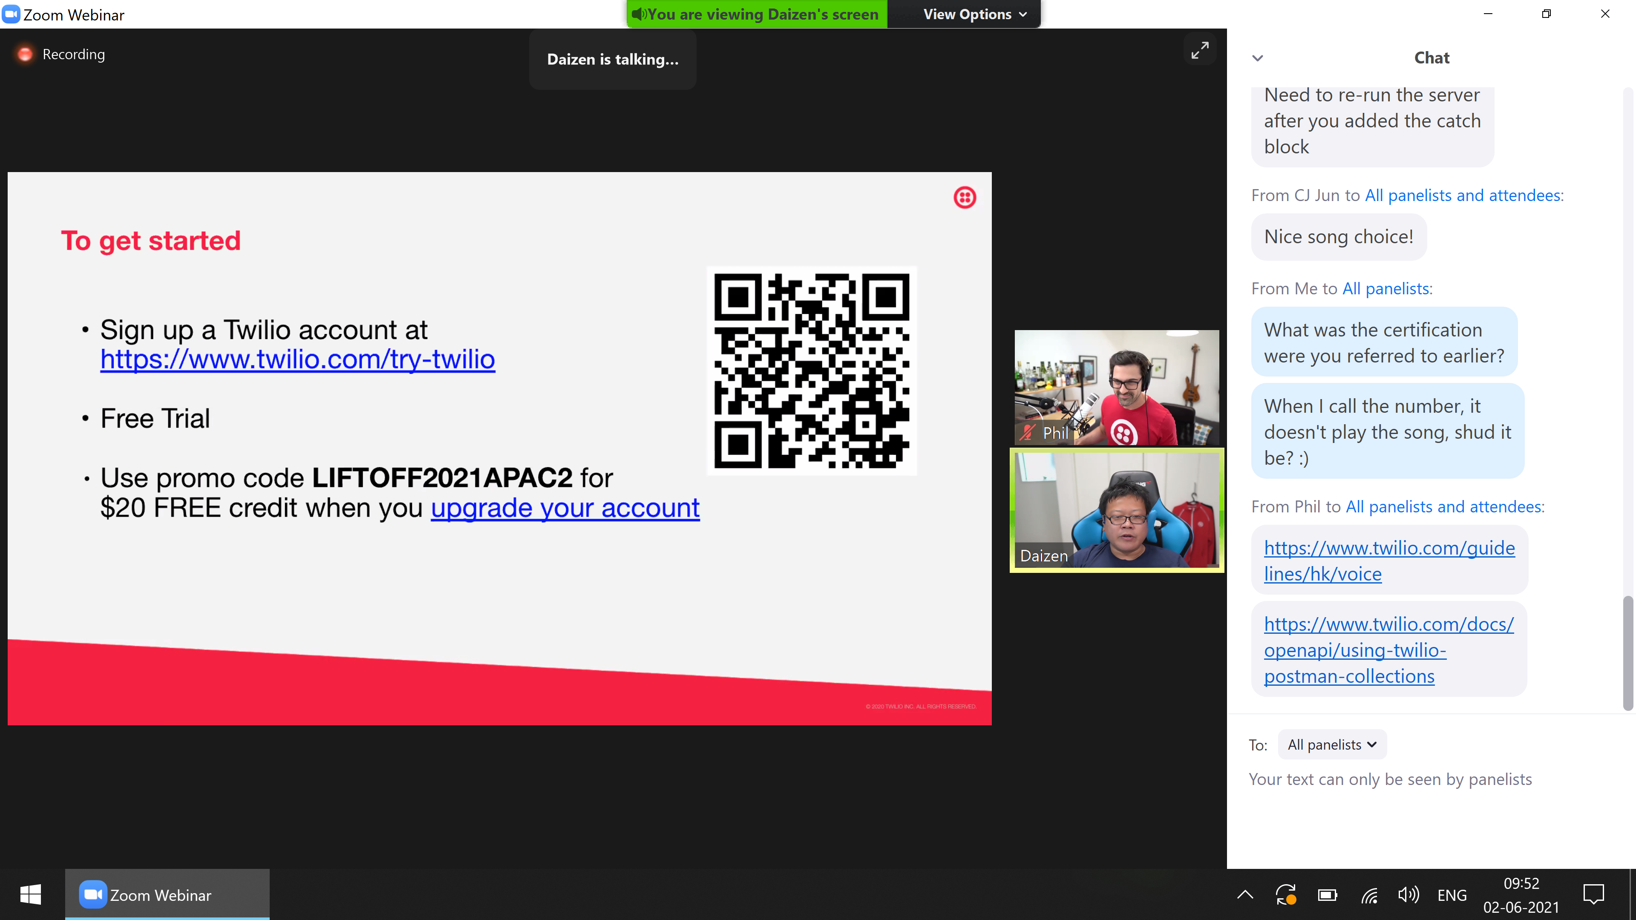

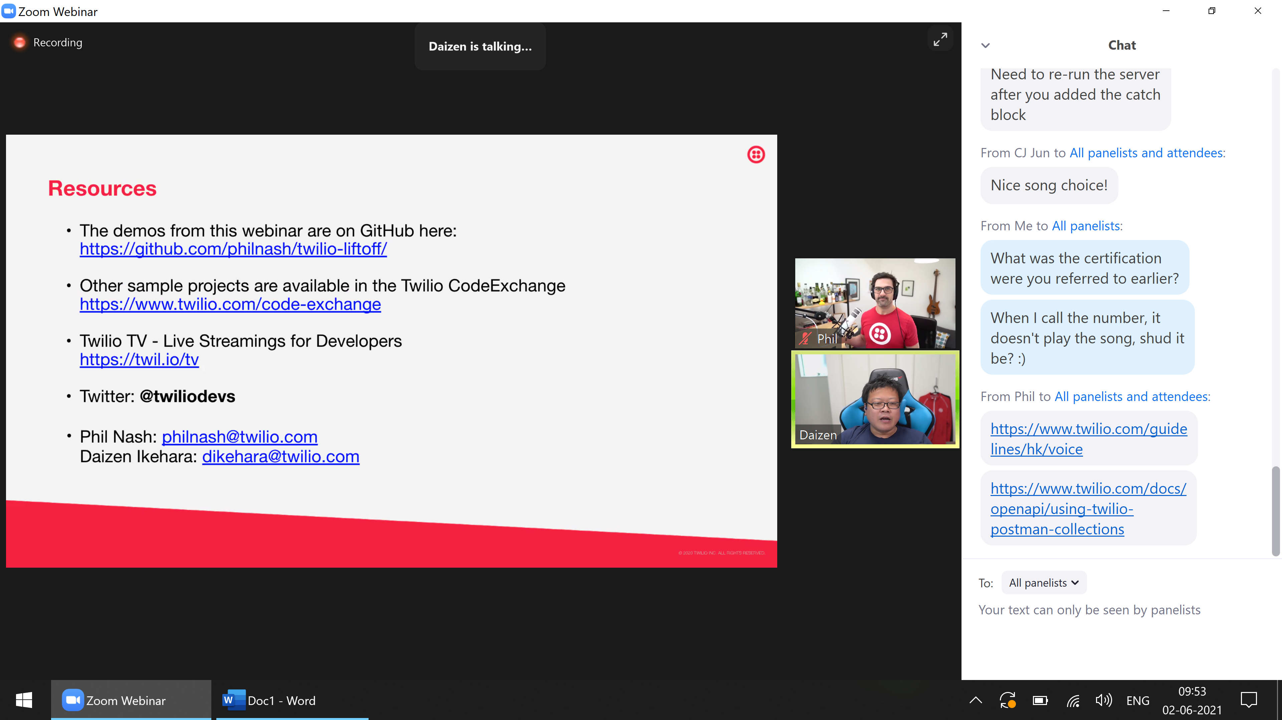

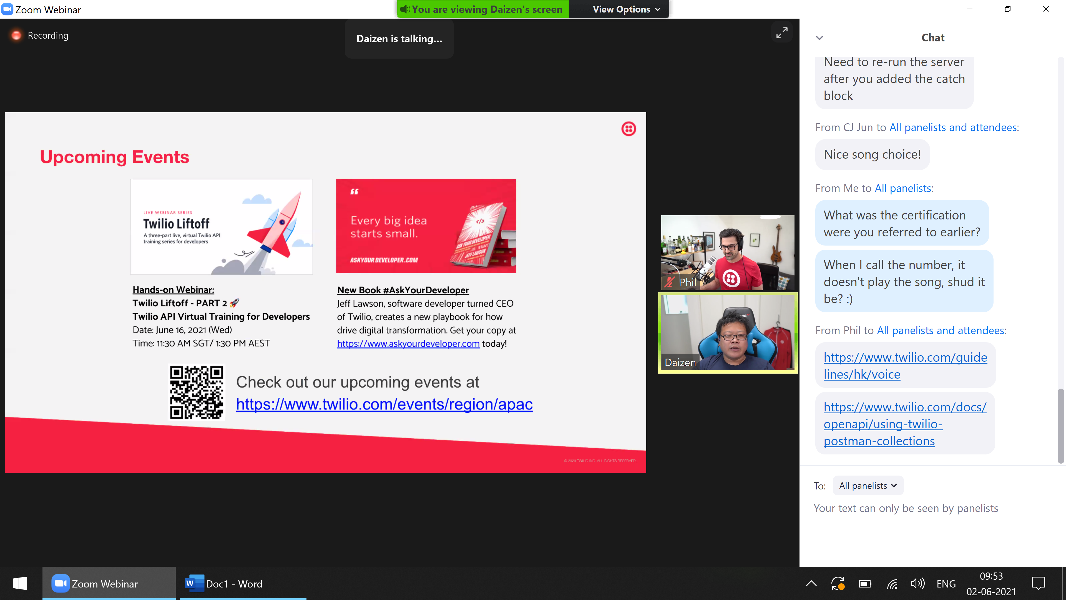

|  |
| --- |
| Thank you for attending our webinar **[Liftoff Part 1: Fundamentals](https://apc01.safelinks.protection.outlook.com/?url=https%3A%2F%2Fu3528416.ct.sendgrid.net%2Fls%2Fclick%3Fupn%3Dg9wRt9AavN88s36J1Koavx4fVLHITr3ytvjwLHAz9TYzOKgS-2Bjgi1RAF6jW1ympNWhwzft2zN2CcCYmO-2BkbjoNV2MxIvtcvtYgjB-2FESn6BYEOZKoIi7H6I6fEkep7JT3ZWEs7ddTEyCzU2HVWvVmtrvmANvfRfmj6jxa8zrAqjY-3D4gV3_kHcQQUdtT4jqKVKCznfLT8yosmX3nxS6NqUKBzL1-2F8mUJ0kUbKIvxLy5hfGj-2FePLAtHtJBZbxQFILGwU6WhiUWD1-2FZZGMBTN0T-2BbdNqQ-2BY2KJMbw1xBTcAYjc-2BN5-2FPc508xI5D2SEk-2F2obsdpbQ547bGcgqkRCUChe8xUVzLrU5GkA9aUoHHg4JtC0qv1selBAAKhiJIFrBD-2FZbwJgoupg-3D-3D&data=04%7C01%7Ckaran-verma%40hcl.com%7Ceb716c555f534ee4453f08d926f41255%7C189de737c93a4f5a8b686f4ca9941912%7C0%7C0%7C637583652041702570%7CUnknown%7CTWFpbGZsb3d8eyJWIjoiMC4wLjAwMDAiLCJQIjoiV2luMzIiLCJBTiI6Ik1haWwiLCJXVCI6Mn0%3D%7C1000&sdata=cLJwyuVcX4MF0wPG7LoDqPnjGIYBMLbLpEYmdCyqW2U%3D&reserved=0" \o "Original URL: https://u3528416.ct.sendgrid.net/ls/click?upn=g9wRt9AavN88s36J1Koavx4fVLHITr3ytvjwLHAz9TYzOKgS-2Bjgi1RAF6jW1ympNWhwzft2zN2CcCYmO-2BkbjoNV2MxIvtcvtYgjB-2FESn6BYEOZKoIi7H6I6fEkep7JT3ZWEs7ddTEyCzU2HVWvVmtrvmANvfRfmj6jxa8zrAqjY-3D4gV3_kHcQQUdtT4jqKVKCznfLT8yosmX3nxS6NqUKBzL1-2F8mUJ0kUbKIvxLy5hfGj-2FePLAtHtJBZbxQFILGwU6WhiUWD1-2FZZGMBTN0T-2BbdNqQ-2BY2KJMbw1xBTcAYjc-2BN5-2FPc508xI5D2SEk-2F2obsdpbQ547bGcgqkRCUChe8xUVzLrU5GkA9aUoHHg4JtC0qv1selBAAKhiJIFrBD-2FZbwJgoupg-3D-3D. Click or tap if you trust this link." \t "_blank)**! We hope you enjoyed the webinar and found it useful. If you would like to watch it again, you can click [this link](https://apc01.safelinks.protection.outlook.com/?url=https%3A%2F%2Fu3528416.ct.sendgrid.net%2Fls%2Fclick%3Fupn%3Dg9wRt9AavN88s36J1Koavx4fVLHITr3ytvjwLHAz9TYzOKgS-2Bjgi1RAF6jW1ympNWhwzft2zN2CcCYmO-2BkbjoNV2MxIvtcvtYgjB-2FESn6BYEOZKoIi7H6I6fEkep7JT3ZWEs7ddTEyCzU2HVWvVmtrvmANvfRfmj6jxa8zrAqjY-3DKtzI_kHcQQUdtT4jqKVKCznfLT8yosmX3nxS6NqUKBzL1-2F8mUJ0kUbKIvxLy5hfGj-2FePLhGQznqagc6yoF3QPGFlFlrkjyoym9pcrIxRx7dLr9TeQRB0UFhGzwG38kghgtnYcv79GHG5KWGiNasACsIpp6xmzuKe3RSiR5qI4qpKnEvt-2F1TM0J4tNuS4Dc-2BbGCr8-2FqdtBUxDG6cAiqfGuv3lCAg-3D-3D&data=04%7C01%7Ckaran-verma%40hcl.com%7Ceb716c555f534ee4453f08d926f41255%7C189de737c93a4f5a8b686f4ca9941912%7C0%7C0%7C637583652041702570%7CUnknown%7CTWFpbGZsb3d8eyJWIjoiMC4wLjAwMDAiLCJQIjoiV2luMzIiLCJBTiI6Ik1haWwiLCJXVCI6Mn0%3D%7C1000&sdata=rQDKp9t7TMHVlCVsqmlynkecwyp2zMVywcdp2bdoD1o%3D&reserved=0) to watch the recording. |
| [Sign up with Twilio now](https://apc01.safelinks.protection.outlook.com/?url=https%3A%2F%2Fu3528416.ct.sendgrid.net%2Fls%2Fclick%3Fupn%3Dg9wRt9AavN88s36J1Koavx4fVLHITr3ytvjwLHAz9TYzOKgS-2Bjgi1RAF6jW1ympN0G8Lt8lnRcHAGO2XbhuZ2TFwrvPaXdzWZ-2FNlr1YbH-2BwdRTfXS5F-2Bg-2BjSPeJtw0-2Bsc6XngLz2oS9Jr7x20aU6ZWL2vykzRBTglK7yHEvcV6I-3DQ0Bt_kHcQQUdtT4jqKVKCznfLT8yosmX3nxS6NqUKBzL1-2F8mUJ0kUbKIvxLy5hfGj-2FePLlybA1et1u-2F-2FO58XmEkIWO-2BGvsMH3XYAniRxCydR-2BiXlzZCO9SLm5ZYEGJtPVLTh-2BRyrjfSpAgPb1WVVjj7JLue2kT9Xmbgj-2FgMvH5ykJrp-2BOjiTXxLuvrG10X-2BznkUbcMKclomZtLO-2FvgozVHa03Ww-3D-3D&data=04%7C01%7Ckaran-verma%40hcl.com%7Ceb716c555f534ee4453f08d926f41255%7C189de737c93a4f5a8b686f4ca9941912%7C0%7C0%7C637583652041712526%7CUnknown%7CTWFpbGZsb3d8eyJWIjoiMC4wLjAwMDAiLCJQIjoiV2luMzIiLCJBTiI6Ik1haWwiLCJXVCI6Mn0%3D%7C1000&sdata=Eku%2FLOW4cNKxL44aCdmqN7zPViFK9VU9w7cIqNXMTtY%3D&reserved=0). Apply promo code **LIFTOFF2021APAC2** to get US$20 free credits when you [upgrade your account](https://apc01.safelinks.protection.outlook.com/?url=https%3A%2F%2Fu3528416.ct.sendgrid.net%2Fls%2Fclick%3Fupn%3Dg9wRt9AavN88s36J1Koavx4fVLHITr3ytvjwLHAz9TYzOKgS-2Bjgi1RAF6jW1ympNzkVZ-2FmfpuAww4GmkdwVam9I1r9EFCKmjyNp5qKCKfAdBc4chbi40bqYTMMTfMo6ZK7OA9X-2BAKRp-2Fhy1SLByf89RdZuIzhUPif4NSCvBaZLw-3DBkLZ_kHcQQUdtT4jqKVKCznfLT8yosmX3nxS6NqUKBzL1-2F8mUJ0kUbKIvxLy5hfGj-2FePL49rvt59qysrfwY2o0lzaLnOwa6gh6dbQbSzRJMsF7eesbNCXL6wnAIScA9uVyh2ErT9Oid-2B0Z88RPy9-2BkAoDK5XGcWG0rAJxupgSqLT9lgYT7MyUWjrY0DHk-2FnvmpL-2FRDTpv-2FlJcSx3f0JdLAzh7Dw-3D-3D&data=04%7C01%7Ckaran-verma%40hcl.com%7Ceb716c555f534ee4453f08d926f41255%7C189de737c93a4f5a8b686f4ca9941912%7C0%7C0%7C637583652041712526%7CUnknown%7CTWFpbGZsb3d8eyJWIjoiMC4wLjAwMDAiLCJQIjoiV2luMzIiLCJBTiI6Ik1haWwiLCJXVCI6Mn0%3D%7C1000&sdata=JVs6ubS5pzFmeX9tayo2FNCfBEKXrtHwsZz8U5HvjUY%3D&reserved=0).  Here are some relevant resources to help you get started:  The code from the Liftoff webinars is here: https://github.com/philnash/twilio-liftoff  TwiML:   * [What is TwiML?](https://apc01.safelinks.protection.outlook.com/?url=https%3A%2F%2Fu3528416.ct.sendgrid.net%2Fls%2Fclick%3Fupn%3Dg9wRt9AavN88s36J1Koavx4fVLHITr3ytvjwLHAz9TYzOKgS-2Bjgi1RAF6jW1ympNTiKeN4rGe-2BWwxD7tTiozeO-2FUh7-2BbiT-2FpPSm2TxUqjevuwArSNQg3SZ3NgbU7f4j5o0-2BpOuaMdl5N4RbW7QdtvswnfBjf0TpDdMhqJmP91dY-3DiZwD_kHcQQUdtT4jqKVKCznfLT8yosmX3nxS6NqUKBzL1-2F8mUJ0kUbKIvxLy5hfGj-2FePLT7X-2BFYlw5D9VHbMIvs-2BOyMsE0BIQnn2j3v-2FAN-2BFU2-2FId4tM46s3FHP9ovZW9PhpA-2B3BQ5iCVprVyaZ8fjH-2F9h4eCefWEdQi-2F4QEWXjqeGVjdXpJWKj-2FgLe8lKjbew8iXuf0NYeVTSNytBVQy9aqZAQ-3D-3D&data=04%7C01%7Ckaran-verma%40hcl.com%7Ceb716c555f534ee4453f08d926f41255%7C189de737c93a4f5a8b686f4ca9941912%7C0%7C0%7C637583652041712526%7CUnknown%7CTWFpbGZsb3d8eyJWIjoiMC4wLjAwMDAiLCJQIjoiV2luMzIiLCJBTiI6Ik1haWwiLCJXVCI6Mn0%3D%7C1000&sdata=roM3ypS5yAJeEP%2BpaVP5felTw1PL5oW5Y5GmTSyCUqo%3D&reserved=0) * [Voice TwiML](https://apc01.safelinks.protection.outlook.com/?url=https%3A%2F%2Fu3528416.ct.sendgrid.net%2Fls%2Fclick%3Fupn%3Dg9wRt9AavN88s36J1Koavx4fVLHITr3ytvjwLHAz9TYzOKgS-2Bjgi1RAF6jW1ympNNMACWg-2FViBizacTWsafxwnrVI-2FOxz7vdBk0D5BunNCTsvk4FhPfdFMWDWPsrBwGrxKFPKaiFhWOR2JrGiPBi770OuOgC5UX7fOLZy8L7Na0-3Deszk_kHcQQUdtT4jqKVKCznfLT8yosmX3nxS6NqUKBzL1-2F8mUJ0kUbKIvxLy5hfGj-2FePLg6b7YH3U2aYkzCxDUxyp7csC74vmutdKkQKLSG3ysFbFqqhL0fnXKdOqPYYdMzcqEVgoy-2B-2FQBvacedrqawBUFvzM3nJPG4uCo35WbEFI6QZMwL6g5ulVbrZ9dDc6SKCbkQV3uJmTYtO5tQ09aOWihg-3D-3D&data=04%7C01%7Ckaran-verma%40hcl.com%7Ceb716c555f534ee4453f08d926f41255%7C189de737c93a4f5a8b686f4ca9941912%7C0%7C0%7C637583652041722484%7CUnknown%7CTWFpbGZsb3d8eyJWIjoiMC4wLjAwMDAiLCJQIjoiV2luMzIiLCJBTiI6Ik1haWwiLCJXVCI6Mn0%3D%7C1000&sdata=2wqpzTHQKB8%2F%2Fm8MxuvcIPTWW30IH%2FcSe9oFVR6iDeU%3D&reserved=0) * [Messaging TwiML](https://apc01.safelinks.protection.outlook.com/?url=https%3A%2F%2Fu3528416.ct.sendgrid.net%2Fls%2Fclick%3Fupn%3Dg9wRt9AavN88s36J1Koavx4fVLHITr3ytvjwLHAz9TYzOKgS-2Bjgi1RAF6jW1ympNWp8TDg0gabyT3DsKCLNtzErLlfRM87tEpLqwdw6nWlVfJddzJo4YfP5Aroajjzp8Ic5SGyTb0VNaerHpnO9GYo4gTn4yJhvK17ZWALqJ1ak-3DBI_3_kHcQQUdtT4jqKVKCznfLT8yosmX3nxS6NqUKBzL1-2F8mUJ0kUbKIvxLy5hfGj-2FePLMjK13O2-2Bbn7nPmXvsHeIfQzhZ-2BJ2Axh0Fi0PFSF0BhmQMgXAuNaMa9JNUUdpP3ieZFiyoNfEZRvAhlmzLRljJeP9oSYpG9dbnKRNKXy8mxtMKWYGJM-2FznRdyzYhO6x-2FpsOuke5DN-2Bbo9jBGSYwUVCA-3D-3D&data=04%7C01%7Ckaran-verma%40hcl.com%7Ceb716c555f534ee4453f08d926f41255%7C189de737c93a4f5a8b686f4ca9941912%7C0%7C0%7C637583652041722484%7CUnknown%7CTWFpbGZsb3d8eyJWIjoiMC4wLjAwMDAiLCJQIjoiV2luMzIiLCJBTiI6Ik1haWwiLCJXVCI6Mn0%3D%7C1000&sdata=qPJ0XkKafi3%2FalrCaikeJcXGojEESwbApup0CXKUc98%3D&reserved=0)   Webhooks:   * [What is a webhook?](https://apc01.safelinks.protection.outlook.com/?url=https%3A%2F%2Fu3528416.ct.sendgrid.net%2Fls%2Fclick%3Fupn%3Dg9wRt9AavN88s36J1Koavx4fVLHITr3ytvjwLHAz9TYzOKgS-2Bjgi1RAF6jW1ympNTb5V2K-2FvQiueejMZBRs2ucTAHjmiCV2PrC1JlnqG-2FZJVDuHASkj21PexPrkrF4LdI5hc0b1wrk2oTtm5UIJSUuHk6UmwqnBmamLWRtgkPrQ-3DdbID_kHcQQUdtT4jqKVKCznfLT8yosmX3nxS6NqUKBzL1-2F8mUJ0kUbKIvxLy5hfGj-2FePLDdzupLJSSmVbjXnl64dKOz0H1yU4bXiVlce5J035xLZg-2Byqs-2FX-2FSWkW1e-2FGIL0FyVbqabd-2F4IArnIyPiFvJ-2F0R-2FB667LrKKs45nBfKQXzbYPHUJPUwAxdIN-2FXC3NqHmk2HZxGBbUfDzfkHxRnkdjQw-3D-3D&data=04%7C01%7Ckaran-verma%40hcl.com%7Ceb716c555f534ee4453f08d926f41255%7C189de737c93a4f5a8b686f4ca9941912%7C0%7C0%7C637583652041732439%7CUnknown%7CTWFpbGZsb3d8eyJWIjoiMC4wLjAwMDAiLCJQIjoiV2luMzIiLCJBTiI6Ik1haWwiLCJXVCI6Mn0%3D%7C1000&sdata=lO8xguZS8ZVwWTDhTBx9CA2mGWpmW94jGBHkeXyl6Pg%3D&reserved=0) * [How to use Twilio webhooks](https://apc01.safelinks.protection.outlook.com/?url=https%3A%2F%2Fu3528416.ct.sendgrid.net%2Fls%2Fclick%3Fupn%3Dg9wRt9AavN88s36J1Koavx4fVLHITr3ytvjwLHAz9TYzOKgS-2Bjgi1RAF6jW1ympNItw-2F61inA9SA-2BQOGDoqahLOAk5j2uVmxEg5jG-2FM3evvYNVfObR4hL0-2Fvs3TXkmtIzmdlBMMZDAPbAED6k3-2FKq-2FcV-2FXRUEXl0uBfp85Vc-2B0A-3DDi3W_kHcQQUdtT4jqKVKCznfLT8yosmX3nxS6NqUKBzL1-2F8mUJ0kUbKIvxLy5hfGj-2FePLMtDwotIBUTA3Y1DsZ6FQWfvYKMDtTH8n4C42Keo-2BRhsPT5s9RQcDBpMOTaZmJRPdQjVvcMxVaIxxFjVqGaf9AbuRzeLXZ-2B-2B523xiOcZwixKpg79giAiFmQatFs05Y9-2FiyoiTANTiF7IZeIh24NtrdA-3D-3D&data=04%7C01%7Ckaran-verma%40hcl.com%7Ceb716c555f534ee4453f08d926f41255%7C189de737c93a4f5a8b686f4ca9941912%7C0%7C0%7C637583652041732439%7CUnknown%7CTWFpbGZsb3d8eyJWIjoiMC4wLjAwMDAiLCJQIjoiV2luMzIiLCJBTiI6Ik1haWwiLCJXVCI6Mn0%3D%7C1000&sdata=tuu6qV%2B%2FVwwxbvOPiEZkWunNtztZ5nJilHszcCvJ%2Bdo%3D&reserved=0) * [Getting started with Twilio webhooks](https://apc01.safelinks.protection.outlook.com/?url=https%3A%2F%2Fu3528416.ct.sendgrid.net%2Fls%2Fclick%3Fupn%3Dg9wRt9AavN88s36J1Koavx4fVLHITr3ytvjwLHAz9TYzOKgS-2Bjgi1RAF6jW1ympNe8L5OfYqmOJM3NZHyrbQIRbXUvud6mXIq33yMEXfGyGoNxqOS0ypYvRyuT-2BJ4Vb8yrqtgzF0qxmdM72RrfvGbjCSOc0rzdRhYBFcVfBLmu8-3D8PZX_kHcQQUdtT4jqKVKCznfLT8yosmX3nxS6NqUKBzL1-2F8mUJ0kUbKIvxLy5hfGj-2FePL0CBswWb96pN-2Bks-2BjPkXQfuEOWRpFZb3lUzXbYx3Dxlea6v5460nb7JTLL-2Ben-2FlJcwFU-2B1aoeM3j-2F4ujlaGsSg0fJ6qHhZKnR8pSk1unc28VYiKq-2F58NyZOl6l3lEuozTdYqad-2BGyR62ny9iiX9Gczw-3D-3D&data=04%7C01%7Ckaran-verma%40hcl.com%7Ceb716c555f534ee4453f08d926f41255%7C189de737c93a4f5a8b686f4ca9941912%7C0%7C0%7C637583652041732439%7CUnknown%7CTWFpbGZsb3d8eyJWIjoiMC4wLjAwMDAiLCJQIjoiV2luMzIiLCJBTiI6Ik1haWwiLCJXVCI6Mn0%3D%7C1000&sdata=Us9cgkNZtVkDKc%2B%2FEnA%2ByiHh38NeprtrufGEp2M0AKQ%3D&reserved=0)   The REST API   * [Making HTTP requests to the Twilio API](https://apc01.safelinks.protection.outlook.com/?url=https%3A%2F%2Fu3528416.ct.sendgrid.net%2Fls%2Fclick%3Fupn%3Dg9wRt9AavN88s36J1Koavx4fVLHITr3ytvjwLHAz9TYzOKgS-2Bjgi1RAF6jW1ympNsa2-2FUQ95-2BYhmhJSUD-2BAcG3VmUCUhs5VK2v13p6tsrR-2BUaLohggxDttDq-2FVCXZmzooy4vBK2QP2gi-2F4CxDKbfSN4sz-2BAAbeLMrrNCTYLLHQ4-3Dz936_kHcQQUdtT4jqKVKCznfLT8yosmX3nxS6NqUKBzL1-2F8mUJ0kUbKIvxLy5hfGj-2FePLsWrjSlEEB5Q7NmnH7iCp2-2FSkbrwpSOVl8tWsl7Bo8Qs8yRX2oyxgMEf9i7-2FhZ45gl4Q-2FIPmrq7BZ063ZlpFZxVf2Gj4aLXZQfKJGh-2BSI7Pl4lvBUTI9-2B9wVPmEPEfuIKGp8oeSqZUqjL8soqGfBSXw-3D-3D&data=04%7C01%7Ckaran-verma%40hcl.com%7Ceb716c555f534ee4453f08d926f41255%7C189de737c93a4f5a8b686f4ca9941912%7C0%7C0%7C637583652041742396%7CUnknown%7CTWFpbGZsb3d8eyJWIjoiMC4wLjAwMDAiLCJQIjoiV2luMzIiLCJBTiI6Ik1haWwiLCJXVCI6Mn0%3D%7C1000&sdata=JlAAfHUzfrYt%2BGbv8TuBXj36oMvAsR0HSnbCLDgHZrY%3D&reserved=0) * [Twilio helper libraries](https://apc01.safelinks.protection.outlook.com/?url=https%3A%2F%2Fu3528416.ct.sendgrid.net%2Fls%2Fclick%3Fupn%3Dg9wRt9AavN88s36J1Koavx4fVLHITr3ytvjwLHAz9TYzOKgS-2Bjgi1RAF6jW1ympNYPthLO4pUPxhVsU1zQ0DozpopBclS14Ss7zxfZntwTZxZQn-2FTPhAJF-2BzDmVSsMMvMngJI0r-2BrawT3C5Y-2BiZLBTOhh4a7MhWOHnqCj4swaiQ-3DCRAi_kHcQQUdtT4jqKVKCznfLT8yosmX3nxS6NqUKBzL1-2F8mUJ0kUbKIvxLy5hfGj-2FePLCors5tPKG1jSj2ScqlygWG9BH472MEE-2F-2FPk-2BBYlKZYTA-2FC1Y0mk0bBt7j1jfPF69cPzNgig9PxZMqXl9rLB7dL8OoCatyRFGbqnAyFP0NjU3cLswFhyhObGAnO9zewRo9JqqkK4DwXer8Ql9oHYnBw-3D-3D&data=04%7C01%7Ckaran-verma%40hcl.com%7Ceb716c555f534ee4453f08d926f41255%7C189de737c93a4f5a8b686f4ca9941912%7C0%7C0%7C637583652041742396%7CUnknown%7CTWFpbGZsb3d8eyJWIjoiMC4wLjAwMDAiLCJQIjoiV2luMzIiLCJBTiI6Ik1haWwiLCJXVCI6Mn0%3D%7C1000&sdata=kvIZLNfzQ81G4Q9kXy51k%2B9%2FVkJewl4TYDTSfx8WGlM%3D&reserved=0) |
| Join us for [Liftoff Part 2: In The Real World (June 16)](https://apc01.safelinks.protection.outlook.com/?url=https%3A%2F%2Fu3528416.ct.sendgrid.net%2Fls%2Fclick%3Fupn%3Dg9wRt9AavN88s36J1Koavx4fVLHITr3ytvjwLHAz9TYzOKgS-2Bjgi1RAF6jW1ympNeQBW7XxpY1PJmGVoG-2FDZ8jgYuQ22ykZD4WH1OyPpq-2B3Oqi-2Fc3QR3LdbwEPD56i4P5d78XiokPGFxRCU1G4yI-2FlJIB-2B0tw9kNgtXg9Mce86s-3DSgXE_kHcQQUdtT4jqKVKCznfLT8yosmX3nxS6NqUKBzL1-2F8mUJ0kUbKIvxLy5hfGj-2FePLwtZG-2B-2FGQ-2F1PbwMN-2Fs5CLPLAkZqHay2l0rWnxvM9QERYWA9ujPS7SSabewmkB1NqQ9q-2FfOJtjWNh9Qo2nuMdiewL7axcWewhuz9D7mVAQDg8OQSWtZzNZ1-2FnClPennsg29w2UJXyXBGpD8WtngKbXXQ-3D-3D&data=04%7C01%7Ckaran-verma%40hcl.com%7Ceb716c555f534ee4453f08d926f41255%7C189de737c93a4f5a8b686f4ca9941912%7C0%7C0%7C637583652041752349%7CUnknown%7CTWFpbGZsb3d8eyJWIjoiMC4wLjAwMDAiLCJQIjoiV2luMzIiLCJBTiI6Ik1haWwiLCJXVCI6Mn0%3D%7C1000&sdata=ZyoBk2JfFyV3RT%2Fpt0g5%2Fk20exPmRFkIlMTM0t35xBo%3D&reserved=0" \o "Original URL: https://u3528416.ct.sendgrid.net/ls/click?upn=g9wRt9AavN88s36J1Koavx4fVLHITr3ytvjwLHAz9TYzOKgS-2Bjgi1RAF6jW1ympNeQBW7XxpY1PJmGVoG-2FDZ8jgYuQ22ykZD4WH1OyPpq-2B3Oqi-2Fc3QR3LdbwEPD56i4P5d78XiokPGFxRCU1G4yI-2FlJIB-2B0tw9kNgtXg9Mce86s-3DSgXE_kHcQQUdtT4jqKVKCznfLT8yosmX3nxS6NqUKBzL1-2F8mUJ0kUbKIvxLy5hfGj-2FePLwtZG-2B-2FGQ-2F1PbwMN-2Fs5CLPLAkZqHay2l0rWnxvM9QERYWA9ujPS7SSabewmkB1NqQ9q-2FfOJtjWNh9Qo2nuMdiewL7axcWewhuz9D7mVAQDg8OQSWtZzNZ1-2FnClPennsg29w2UJXyXBGpD8WtngKbXXQ-3D-3D. Click or tap if you trust this link." \t "_blank) and [Part 3: At Scale (June 30).](https://apc01.safelinks.protection.outlook.com/?url=https%3A%2F%2Fu3528416.ct.sendgrid.net%2Fls%2Fclick%3Fupn%3Dg9wRt9AavN88s36J1Koavx4fVLHITr3ytvjwLHAz9TYzOKgS-2Bjgi1RAF6jW1ympNeQBW7XxpY1PJmGVoG-2FDZ8jgYuQ22ykZD4WH1OyPpq-2B3Oqi-2Fc3QR3LdbwEPD56i4P5d78XiokPGFxRCU1G4yI-2FlJIB-2B0tw9kNgtXg9Mce86s-3DTzf6_kHcQQUdtT4jqKVKCznfLT8yosmX3nxS6NqUKBzL1-2F8mUJ0kUbKIvxLy5hfGj-2FePLCdbeYgmoFbneab-2BSpRW7LObZVCjaVD101e4duRZlJRuQ-2BnIVsNZqkRRYf6QwwIc9-2BTXLt10GUHfdejUujLfBhTjOMLMF8WuM-2F8y8W5akbp49NllMohEIzPkSqxwbWPU8edak89jxjzhZC9ej2UQWKA-3D-3D&data=04%7C01%7Ckaran-verma%40hcl.com%7Ceb716c555f534ee4453f08d926f41255%7C189de737c93a4f5a8b686f4ca9941912%7C0%7C0%7C637583652041752349%7CUnknown%7CTWFpbGZsb3d8eyJWIjoiMC4wLjAwMDAiLCJQIjoiV2luMzIiLCJBTiI6Ik1haWwiLCJXVCI6Mn0%3D%7C1000&sdata=x2vh7qrUXbnj57nXtD7y%2BrqhdTG3mzj%2FqJhEh5TCtwA%3D&reserved=0) Get a certificate once you have completed the training series.  We look forward to hosting you again at our upcoming virtual events! Keep your eyes open for future event invites coming from @teamtwilio.com, check out [our event website](https://apc01.safelinks.protection.outlook.com/?url=https%3A%2F%2Fu3528416.ct.sendgrid.net%2Fls%2Fclick%3Fupn%3Dg9wRt9AavN88s36J1Koavx4fVLHITr3ytvjwLHAz9TYzOKgS-2Bjgi1RAF6jW1ympN6ApdezBYMUnhqG-2F6192nlFzwPnRI0HqQjuA-2BDU-2FvvbUMbW7IIHENwpNgOGuVyapkUXOUen8rSd7AahclLq3y3leqJFPby0v4VEBc4q9ZqVg-3D9KC0_kHcQQUdtT4jqKVKCznfLT8yosmX3nxS6NqUKBzL1-2F8mUJ0kUbKIvxLy5hfGj-2FePLyQkjlWJeHRXlIpIcMGh9r5saq2IPmtJEqfaqXoxxrtRHWb-2BC6l-2F6PrA-2BH6KxJbCvqjyxAk6k1KbFMdQQs9F436F1Qzw2cHXezFEcYfD3o0r-2FYXsxsBHnxkSAMwxl03XS6F-2FZc2wphAz5sm-2FfOxtDvQ-3D-3D&data=04%7C01%7Ckaran-verma%40hcl.com%7Ceb716c555f534ee4453f08d926f41255%7C189de737c93a4f5a8b686f4ca9941912%7C0%7C0%7C637583652041752349%7CUnknown%7CTWFpbGZsb3d8eyJWIjoiMC4wLjAwMDAiLCJQIjoiV2luMzIiLCJBTiI6Ik1haWwiLCJXVCI6Mn0%3D%7C1000&sdata=5D%2FaU4WJUXiNlsSj0wLaZ9OQuq6WidUoF0wWFG%2B82pU%3D&reserved=0), or find other [live programs on Twilio TV.](https://apc01.safelinks.protection.outlook.com/?url=https%3A%2F%2Fu3528416.ct.sendgrid.net%2Fls%2Fclick%3Fupn%3Dg9wRt9AavN88s36J1Koavx4fVLHITr3ytvjwLHAz9TYzOKgS-2Bjgi1RAF6jW1ympNA9oS2-2BQCxuqj3RiIEYRrUYeK-2BxC7nD8KGxlw6DFsbTNFuCceZXnbLZm7bU1HW8V8zv9JUDwhUxXUcgYOUGamkEA3NAWgW4yr6xarQJvuk-2FI-3DckvE_kHcQQUdtT4jqKVKCznfLT8yosmX3nxS6NqUKBzL1-2F8mUJ0kUbKIvxLy5hfGj-2FePLzD7ynvIzJSPx16Qth3eLIKk0NgBme5EgaECcV6D-2FgHraoN-2B2mCCDMTcNsGaPK5DB5u-2FVyLiOfLmkG4A6hVvJ88N7-2BWg2o3NbRJD-2BitBC4CzW60v-2Bi-2BeeGq-2BU-2FNFGuXjt5Z0AbfyzBP-2FfrjeU0L5jtQ-3D-3D&data=04%7C01%7Ckaran-verma%40hcl.com%7Ceb716c555f534ee4453f08d926f41255%7C189de737c93a4f5a8b686f4ca9941912%7C0%7C0%7C637583652041762308%7CUnknown%7CTWFpbGZsb3d8eyJWIjoiMC4wLjAwMDAiLCJQIjoiV2luMzIiLCJBTiI6Ik1haWwiLCJXVCI6Mn0%3D%7C1000&sdata=oRjbnlmxfbrGaTMA6vQvv%2Bn2Ya2X1JhaItvSMJrXg2M%3D&reserved=0)  Feel free to reach out to our developer evangelists [Phil Nash](mailto:philnash@twilio.com) and [Daizen Ikehara](mailto:dikehara@twilio.com) if you have any questions.  Stay safe, stay healthy, and keep building.  Cheers, Team Twilio |
|  |